**DATABASE DESIGN**

Database Name : Ojek-Online.accddb

No of Tables : 8

1. User Details

|  |  |  |
| --- | --- | --- |
| Field Name | Data Type | Description |
| no | Autonumber | Number of the data |
| name | Text | User’s detail |
| email | Text | User’s E-mail |
| sex | Text | User’s gender |
| phone number | Text | User’s phone number |
| joined Date | Date/Time | Date in which the user signed up |

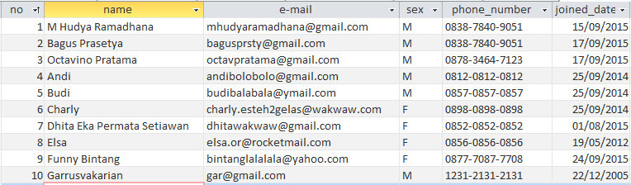

1. Driver Details

|  |  |  |
| --- | --- | --- |
| Field Name | Data Type | Description |
| no | Autonumber | Number of the data |
| Id_driver | Text | Driver’s id |
| name | Text | Driver’s name |
| birthdate | Date/Time | Driver’s birthdate |
| address | Text | Driver’s address |
| phone number | Text | Driver’s phone number |
| sex | Text | Driver’s gender |
| joined date | Date/Time | Date in which the driver signed up |

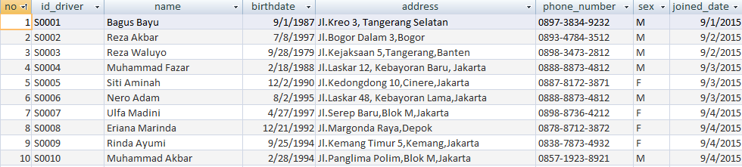

1. Restaurant Data

|  |  |  |
| --- | --- | --- |
| Field Name | Data Type | Description |
| Id_resturant | Text | Restaurant’s id |
| name | Text | Name of the restaurant |
| address | Text | Restaurant’s address |
| phone number | Text | Restaurant’s phone number |

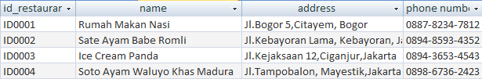

4) Driver’s Dependent

|  |  |  |
| --- | --- | --- |
| Field Name | Data Type | Description |
| No | Autonumber | Number of the data |
| id_driver | Text | Driver’s id |
| dependent | Text | Dependent’s name |
| sex | Text | Staff’s gender |
| birthdate | Date/Time | Birthdate of the dependent |
| status with | Text | Dependent’s status with driver |

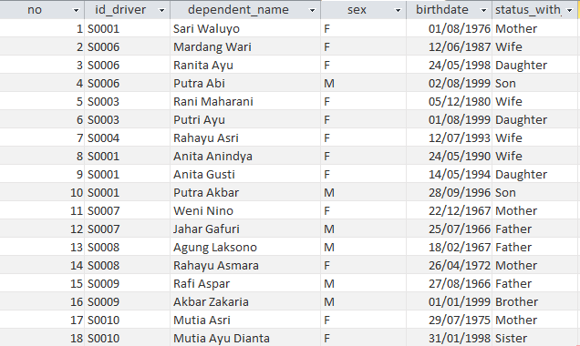

5) Food or Drink Menu

|  |  |  |
| --- | --- | --- |
| Field Name | Data Type | Description |
| Id_menu | Text | Menu’s ID |
| Id_restaurant | Text | Restaurant’s ID |
| Menu_name | Text | Name of Menu |
| price | Text | Price of Menu |

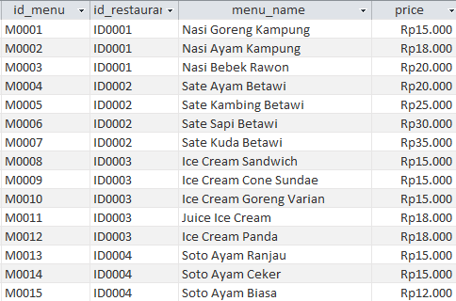

6) Food or Drink Transaction

|  |  |  |
| --- | --- | --- |
| Field Name | Data Type | Description |
| no_booking | Autonumber | Number of booking |
| id_menu | Text | Identification of the menu |
| name | Text | Name of the food/drink |
| id_driver | Text | Driver’s id |
| booking_date | Date/Time | Date of the booking |
| booking_time | Date/Time | Time of the booking |
| total | Text | Total of the items booked |
| Driver’s Fee | Number | Driver’s delivery fee |

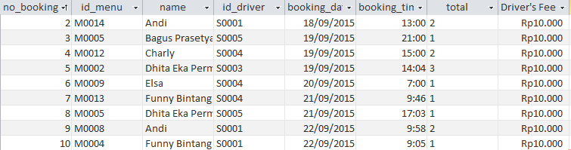

7) Courier or Transport Transaction

|  |  |  |
| --- | --- | --- |
| Field Name | Data Type | Description |
| no_booking | Autonumber | Number of booking |
| types | Text | Types of service provided |
| id_staff | Text | Staff’s id |
| departure | Text | User Departure Location |
| destination | Text | User Destination Location |
| booking_time | Date/Time | Time of the booking |
| booking date | Date/Time | Date of the booking |
| fee | Number | Fee of the provided services |

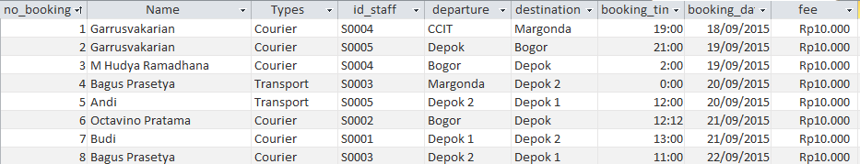

8) Feedback Table

|  |  |  |
| --- | --- | --- |
| Field Name | Data Type | Description |
| Name | Text | Name of User |
| E-mail | Text | User’s Email |
| Title | Text | Title of comment |
| Comment | Text | Comment field |



Relationship

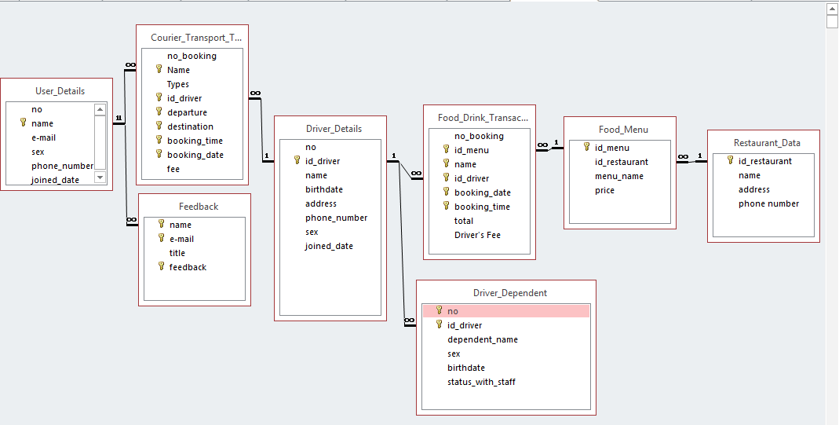

This Application used Microsoft Access with 8 table that is User_Details, Courier_Transport_Transaction, Feedback, Driver_Details, Driver_Dependent, Food_Drink_Transaction, Food_Menu, and Restaurant_Data. Here is our relationship :

1. Field [name] in User_details Table connected with [name] field in Feedback and Courier_Transport_Transaction Table.
2. Field [id_driver] in Driver_Details Table connected with [id_driver] field in Courier_transport_transaction, Driver_Dependent, and Food_Drink_Transaction table.
3. Field [id_menu] in Food_menu Table connected with [id_menu] field in Food_Drink_Transaction table.
4. Field [id_restaurant] in Food_menu Table connected with [id_restaurant] field in Restaurant_Data Table.

**FORM DESIGN**

|  |  |  |  |
| --- | --- | --- | --- |
| Form Name | Form Type | Description | Tables/Query Used |
| Courier & Transport Transaction | Transaction Form | To add courier and transport order | Courier Transport Transaction |
| Daftar Makanan | Search Form | To search and show all menu | Food Menu |
| Driver and User Data | Menu | Show option to select Driver Details, Driver’s Dependent or User Details Form | - |
| Driver Dependent | Search Form | Show and Search Driver’s Dependent | Driver Dependent |
| Driver Details | Search Form | Show and search Driver Details | Driver Details |
| Food & Drink Transaction | Transaction Form | To add food or drink order | Food Menu |
| Food or Drink Menu | Menu | Show option to select Food & Drink Order or Food Menu Search | - |
| Form Menu | Menu | Show home menu of application | - |
| Query and Reports | Menu | Show all Query and reports | All Query and Reports |
| Register Account | Transaction Form | To Register New User. | User Details |
| User Details | Search Form | Show and search User Details | User Details |
| User Feedback | Transaction Form | In this form, User can give any feedback,comment and complain about our service. | Feedback |

**Driver_Details**

* Name, Address, sex and phone number should not be left blank.
* Phone_Number should be entered in the format, xxxx-xxxx-xxxx.
* Sex must be written M or F

**User_Details**

* Name, e-mail, sex, phone number should not be left blank.
* Sex must be written M or F

**Restaurant_data**

* ID_restaurant should start with ID and followed by 4 digit number
* Phone_Number should be entered in the format, xxxx-xxxx-xxxx.

**Food_Drink_Transaction**

* Id_menu,name,id_driver,Booking_date, booking_time,and total should not be left blank.

**Courier_Transport_Transaction**

* Name,Types,id_driver,departure,destination,booking_time,and booking_date should not be left blank.

**Food_Menu**

* Id_menu,id_restaurant,menu_name, and price should not be left blank.
* ID_Menu should start with M and followed by 4 digit number
* ID_restaurant should start iwht ID and followed by 4 digit number

**Driver_Dependent**

* Id_driver, dependent name,sex, birthdate, and status_with_driver should not be left blank.
* Sex must be written M or F

**Feedback**

* Name,title, e-mail and comment should not be left blank.

**VALIDATIONS PERFORMED**

|  |  |  |  |
| --- | --- | --- | --- |
| Query Name | Query type | Description | Tables Used |
| Birthdate 1990-2000 | Simple | To show query about driver which born in 1990-2000. | Driver Details |
| Driver Birthdate > 1985 | Simple | To show query about driver which born above 1985. | Driver Details |
| Driver Dependent | Simple | To show driver’s dependent on his family. | Driver Details and Driver Dependent |
| Driver Details | Simple | To Show Driver Details. | Driver Details |
| Female User | Simple | To Show Females User | Driver Details |
| Food Below Rp 20.000 | Simple | To show food or drink bellow Rp 20.000 | Food Menu |
| Food Bought by Dhita Eka Permata Setiawan | Simple | To show food bought by Dhita Eka Permata Setiawan | Food Drink Transaction |
| Food Delivered by Muhammad Fazar | Simple | To show food which delivered by Muhammad Fazar | Food Drink Transaction |
| Food Ordered at 18-20 September 2015 | Simple | To show food which ordered at 18 untill 20 September 2015 | Food Drink Transaction |
| Joined Date 03-04 September 2015 | Simple | To show Driver which joined at 3-4 September 2015 | Driver Details |
| Male Driver | Simple | To show all male driver | Driver Details |
| Male User | Simple | To show all male user | User Details |
| Menu List | Simple | To show all menu | Food Menu |
| Sate Kambing Betawi | Simple | To show people who order “Sate Kambing Betawi” | Food Drink Transaction |
| User Departure From Bogor | Simple | To show people who order Ojek and depart from bogor | Courier Transport Transaction |
| User Destination to depok | Simple | To show people who order ojek and the destination is depok | Courier Transport Transaction |
| User Details | Simple | To show all User Details | User Details |
| User Joined Between 15-19 Sept 2015 | Simple | To Show all user who joined at 15-19 September 2015 | User Details |
| User Order Courier | Simple | To show all user who order courier types transaction | Courier Transport Transaction |

**Queries Used**

|  |  |  |  |
| --- | --- | --- | --- |
| Report Name | Report type | Description | Tables/Queries Used |
| Birthdate 1990-2000 | Columnar | To show Report about driver which born in 1990-2000. | Driver Details |
| Driver Birthdate > 1985 | Columnar | To show report about driver which born above 1985. | Driver Details |
| Driver Dependent | Columnar | To show report about drivers dependent on his family. | Driver Details and Driver Dependent |
| Driver Details | Columnar | To Show report about Driver Details. | Driver Details |
| Female User | Columnar | To Show Report about Females User | Driver Details |
| Food Below Rp 20.000 | Columnar | To show Report about food or drink bellow Rp 20.000 | Food Menu |
| Food Bought by Dhita Eka Permata Setiawan | Columnar | To show report about food bought by Dhita Eka Permata Setiawan | Food Drink Transaction |
| Food Delivered by Muhammad Fazar | Columnar | To show report about food which delivered by Muhammad Fazar | Food Drink Transaction |
| Food Ordered at 18-20 September 2015 | Columnar | To show report which ordered at 18 untill 20 September 2015 | Food Drink Transaction |
| Joined Date 03-04 September 2015 | Columnar | To show report about Driver which joined at 3-4 September 2015 | Driver Details |
| Male Driver | Columnar | To show report about all male driver | Driver Details |
| Male User | Columnar | To show report about all male user | User Details |
| Menu List | Columnar | To show report about all menu | Food Menu |
| Sate Kambing Betawi | Columnar | To show report about people who order “Sate Kambing Betawi” | Food Drink Transaction |
| User Departure From Bogor | Columnar | To show report about people who order Ojek and depart from bogor | Courier Transport Transaction |
| User Destination to depok | Columnar | To show report about people who order ojek and the destination is depok | Courier Transport Transaction |
| User Details | Columnar | To show report about all User Details | User Details |
| User Joined Between 15-19 Sept 2015 | Columnar | To Show report about all user who joined at 15-19 September 2015 | User Details |
| User Order Courier | Columnar | To show report about all user who order courier types transaction | Courier Transport Transaction |

**Reports Outline**

* Design Form and Report
* Make a search engine and direct to report form
* Make an error message when search data and there are no data in the table

**Problems Encountered**

**CONFIGURATION**

|  |  |  |
| --- | --- | --- |
| Hardware : Laptop Compatible with a Intel Core i3, 2 GB RAM, and 500GB of Hard  Disk  Operating System : Windows 8 Pro  Software : Microsoft Office Access 2013 | | |
| PROJECT FILE DETAILS | | |
| S.No | File Name | Remarks |
| 1 | Ojeg-Online.accdb | Microsoft Office Access 2013 database that contains tables, queries, forms, and reports. |

**FORM**

1. Menu Form

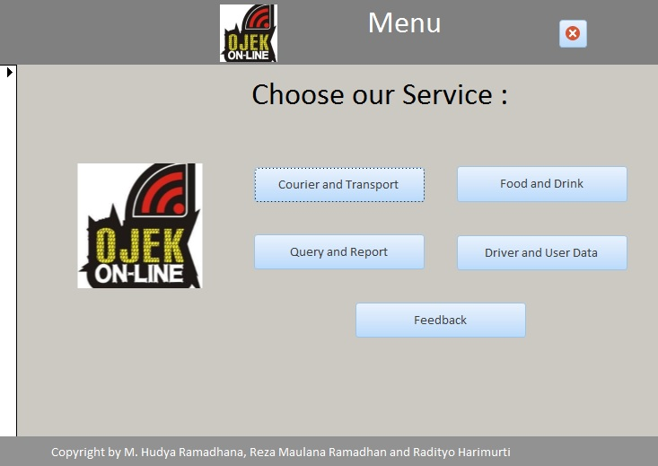

2. Courier and Transport Order Form

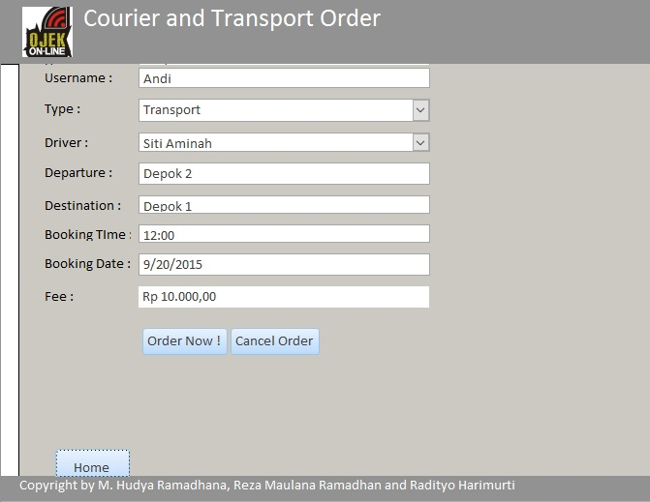

3. Food or Drink Menu

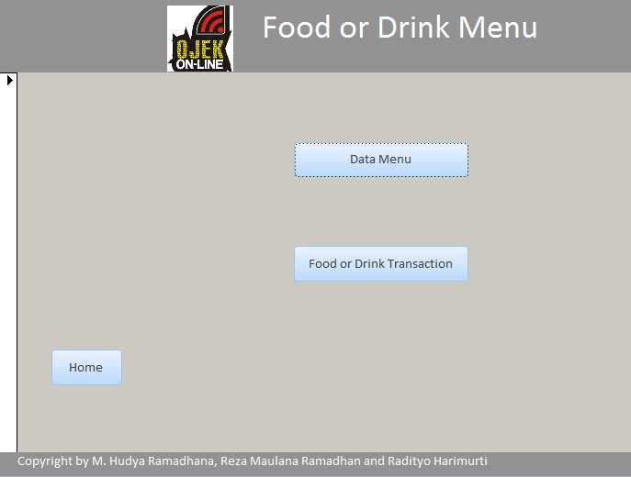

4. Menu Form

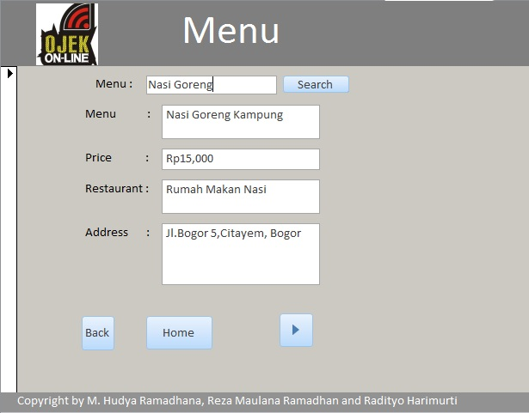

5. Order Food or Drink

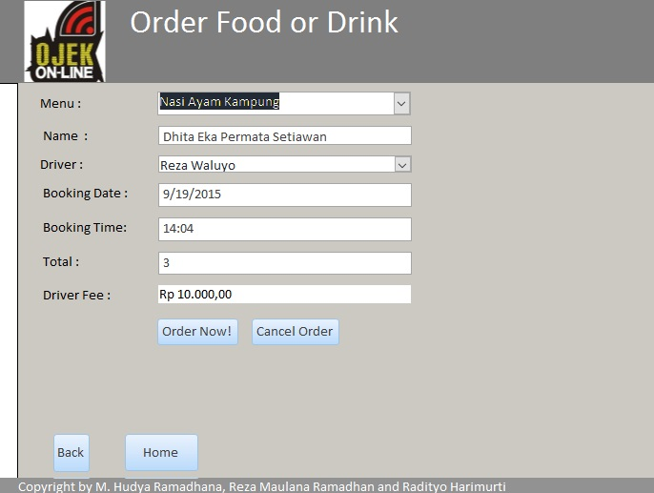

6. Query and Report Form

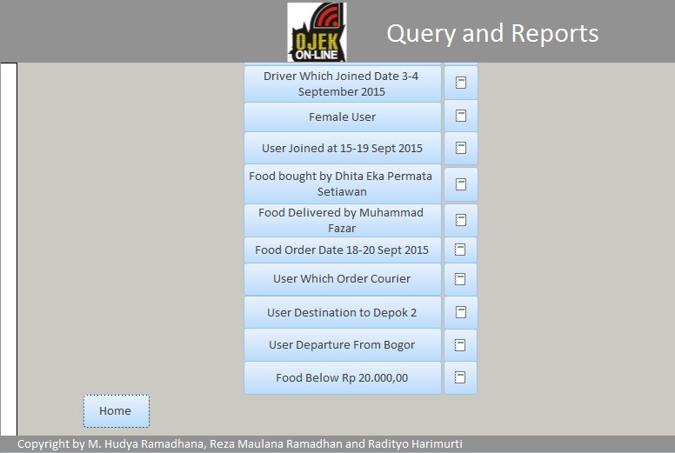

7. Driver and User Data

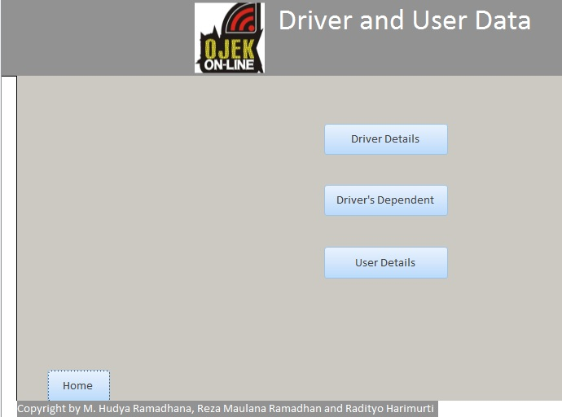

8. Driver Details Form

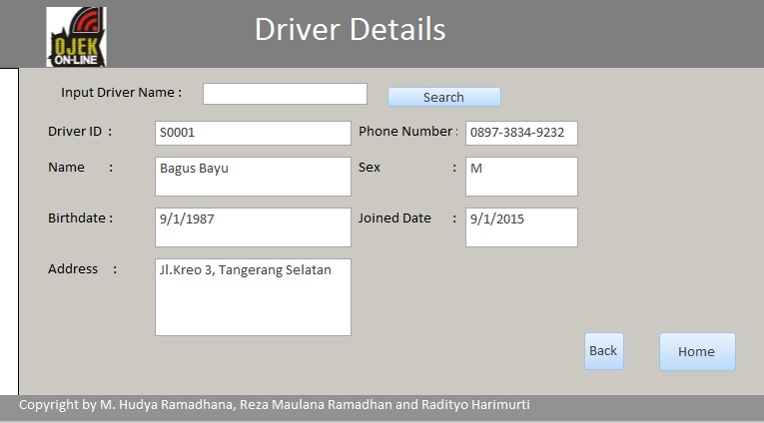

9. Driver’s Dependent Form

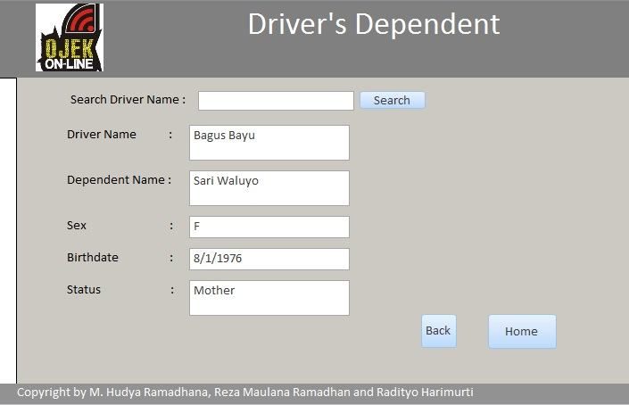

10. User Details Form

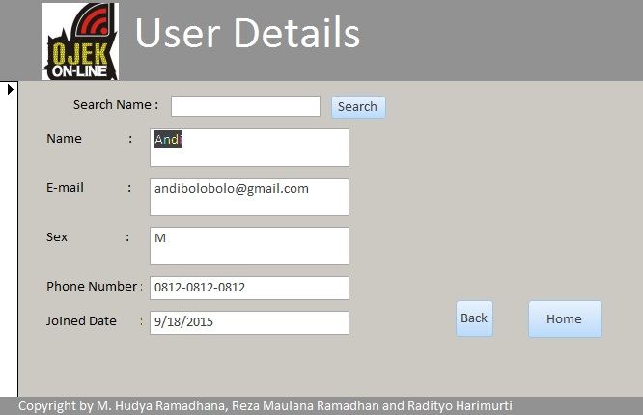

11. Feedback Form

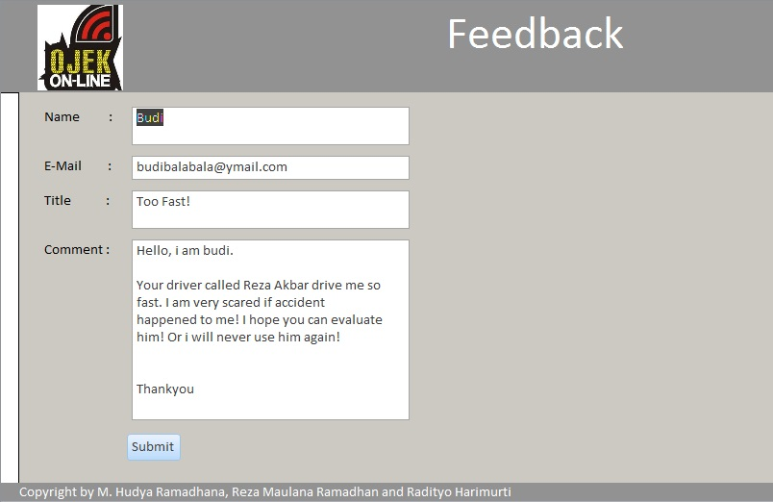

**REPORTS**

1. Food which Delivered by Reza Waluyo Report

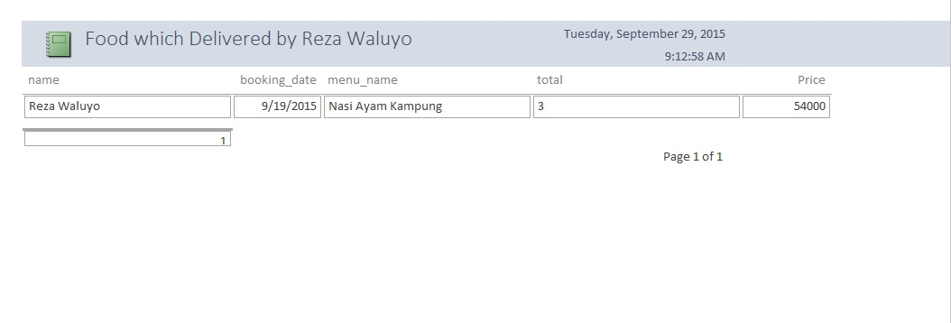

2. Driver Birthdate > 1985 Report

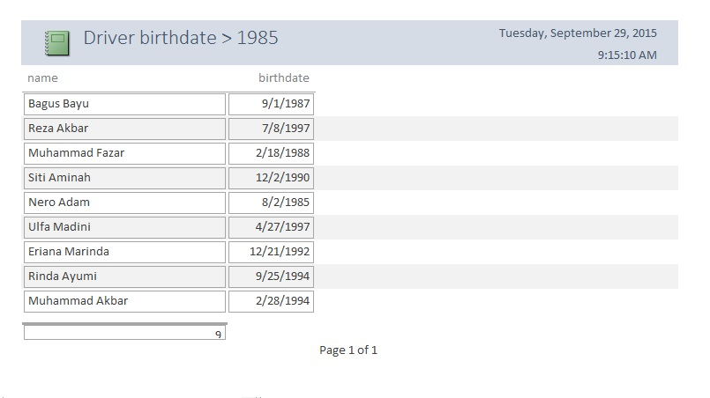

3. Sate Kambing Betawi Report

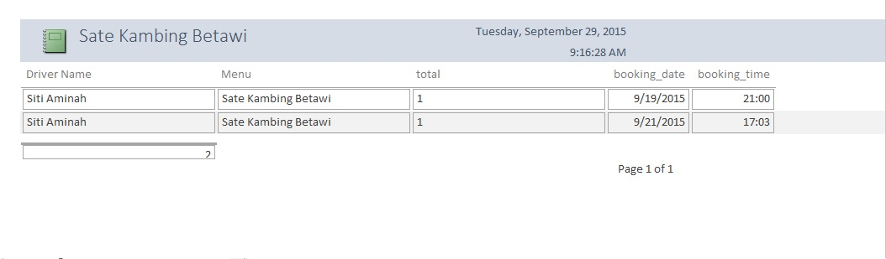

4. Male User Report

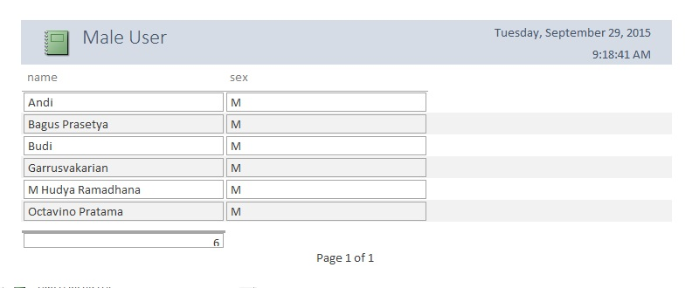

5. Birthdate 1990-2000 Report

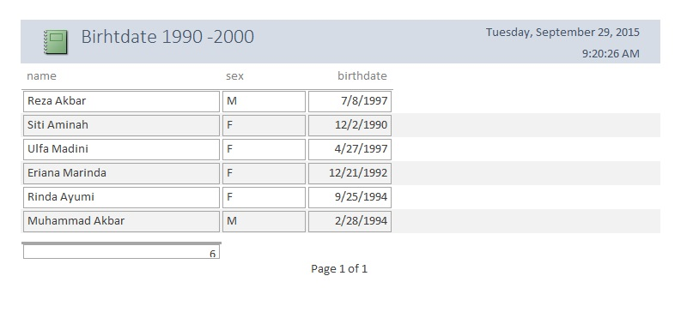

6. Joined Date 03-09-2015 until 04-09-2015 Report

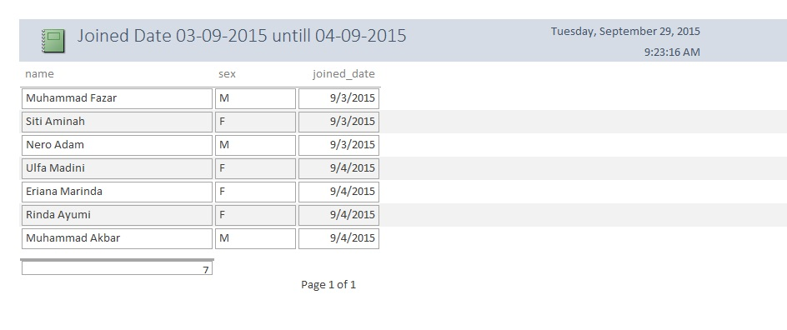

7. Female User Report

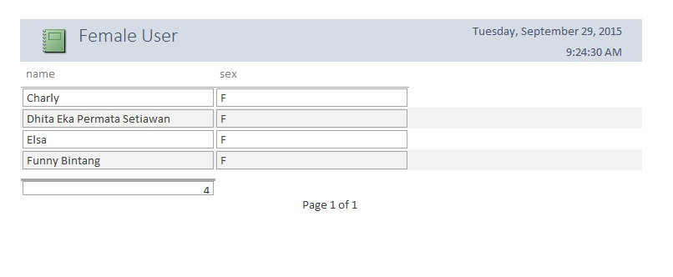

8. User Joined Date Between 15-19 Sept 2015 Report

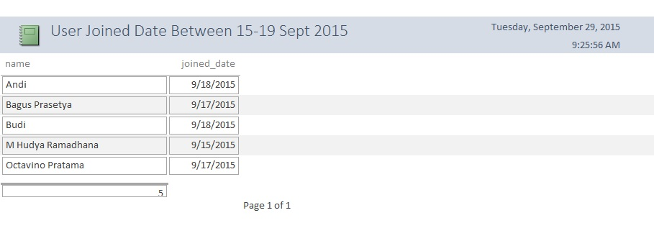

9. Food bought by Dhita Eka Permata Setiawan Report

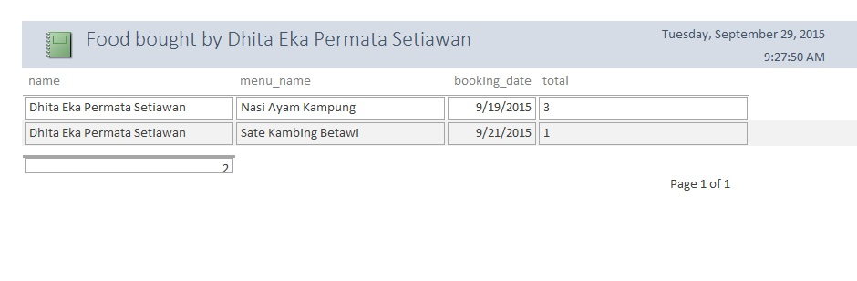

11. Food Delivery by Muhammad Fazar Report

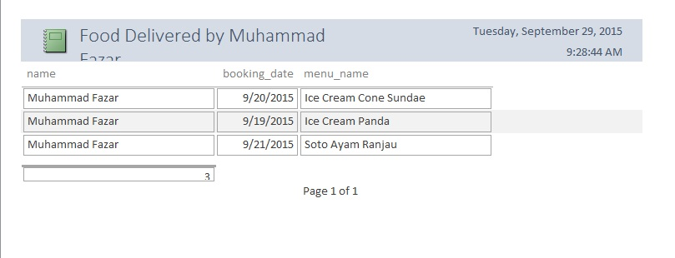

12. Food Ordered at 18-20 September 2015 Report

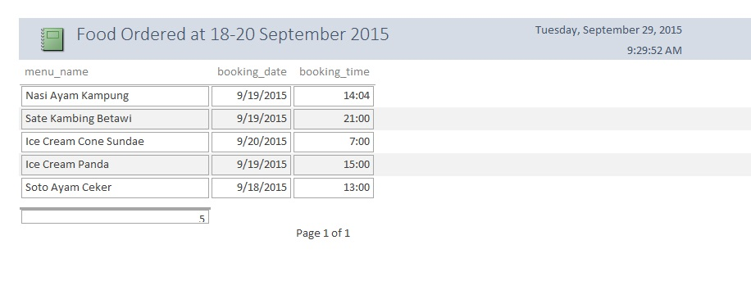

13. User order Courier Report

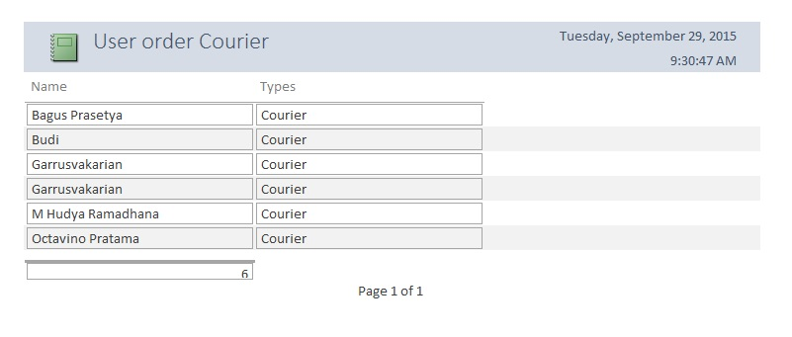

14. User Destination to Depok 2 Report

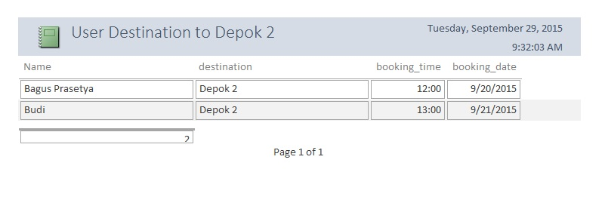

15. User Departure from Bogor Report

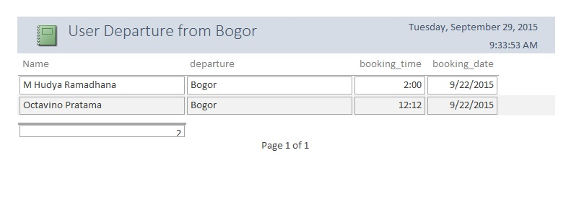

16. Food below Rp 20000 Report

